

Tittle Lorem Ipsum

*Author Name1*, Author Name2*

1Author Affiliation, Country

2Author Affiliation, Country

Correspondence: E-mail: email@xx.yy

| **A B S T R A C T S** |  | **A R T I C L E I N F O** |
| --- | --- | --- |
| Lorem Ipsum is simply dummy text of the printing and typesetting industry. Lorem Ipsum has been the industry's standard dummy text ever since the 1500s, when an unknown printer took a galley of type and scrambled it to make a type specimen book. It has survived not only five centuries, but also the leap into electronic typesetting, remaining essentially unchanged. It was popularised in the 1960s with the release of Letraset sheets containing Lorem Ipsum passages, and more recently with desktop publishing software like Aldus PageMaker including versions of Lorem Ipsum. Lorem Ipsum is simply dummy text of the printing and typesetting industry. Lorem Ipsum has been the industry's standard dummy text ever since the 1500s, when an unknown printer took a galley of type and scrambled it to make a type specimen book. It has survived not only five centuries, but also the leap into electronic typesetting, remaining essentially unchanged. It was popularised in the 1960s with the release of Letraset sheets containing Lorem Ipsum passages, and more recently with desktop publishing software like Aldus PageMaker including versions of Lorem Ipsum.  © 2021 Tim Pengembang Jurnal UPI |  | ***Article History:***  *Received 00 Jun 20xx*  *Revised 00 Jul 20xx*  *Accepted 00 Jul 20xx*  *Available online 00 Sep 20xx*  ____________________  ***Keyword:***  *Attached growth,*  *Biological wastewater treatment,*  *Biofilm,*  *Rotating biological contactors.* |



**1. INTRODUCTION**

Lorem ipsum dolor sit amet, consectetur adipiscing elit. Sed dapibus et neque eget congue. In ac nulla nec nunc pretium porttitor ut et augue. Duis ligula ante, eleifend ut ex sed, cursus tempus felis. Aliquam eget interdum sapien. Sed elementum varius leo, sit amet rutrum ipsum ultricies in (Westall & Brack, 2018). Aenean id mi arcu. Phasellus semper efficitur eros eu laoreet. Vivamus vitae malesuada turpis. Morbi interdum orci iaculis tempor facilisis (Khechekhouche, *et al.*, 2020; Sadasivuni, *et al.*, 2020; Yahiaoui, *et al.*, 2020; Kim, *et al.*, 2019). ed egestas mattis condimentum. Etiam et tristique turpis. Ut tincidunt velit vitae hendrerit euismod. Sed molestie volutpat orci ut placerat. Ut sit amet lorem urna. Donec luctus pharetra venenatis. Ut vel orci venenatis, tincidunt orci sit amet, pharetra ipsum. Pellentesque commodo nulla vitae ex blandit, ut sagittis turpis vestibulum (Nguyen & Juang 2013).

Cras aliquet nisi rutrum, sagittis enim id, sodales augue. Suspendisse venenatis metus nec ante volutpat, vitae condimentum erat condimentum. Nam ligula erat, eleifend et felis non, tincidunt pharetra est. Vestibulum ante ipsum primis in faucibus orci luctus et ultrices posuere cubilia curae; Maecenas cursus leo urna, vitae scelerisque magna ultricies a. Nullam imperdiet augue eget dictum scelerisque. Donec pulvinar enim lectus.

**2. METHODS**

Lorem ipsum dolor sit amet, consectetur adipiscing elit. Sed dapibus et neque eget congue. In ac nulla nec nunc pretium porttitor ut et augue. Duis ligula ante, eleifend ut ex sed, cursus tempus felis. Aliquam eget interdum sapien. Sed elementum varius leo, sit amet rutrum ipsum ultricies in. Proin placerat risus et augue aliquet posuere. Nulla sodales efficitur metus. Integer vitae sodales nisi. Curabitur mauris massa, vulputate ut enim sed, vehicula dignissim ante. Mauris in lacus erat. Curabitur eleifend dui at lorem rutrum ornare.

In molestie ipsum lorem. Aenean id mi arcu. Phasellus semper efficitur eros eu laoreet. Vivamus vitae malesuada turpis. Morbi interdum orci iaculis tempor facilisis. Suspendisse euismod commodo nulla. Nullam eget congue justo. Phasellus vestibulum quis risus ut pharetra.

**2.1. Presentation of the wastewater treatment plant**

The treatment in this station goes through several phases shown schematically **Figure 1**.

**2.2 Wastewater and industrial water purification processes in the station**

Sed egestas mattis condimentum. Etiam et tristique turpis. Ut tincidunt velit vitae hendrerit euismod. Sed molestie volutpat orci ut placerat. Ut sit amet lorem urna. Donec luctus pharetra venenatis. Ut vel orci venenatis, tincidunt orci sit amet, pharetra ipsum. Pellentesque commodo nulla vitae ex blandit, ut sagittis turpis vestibulum.

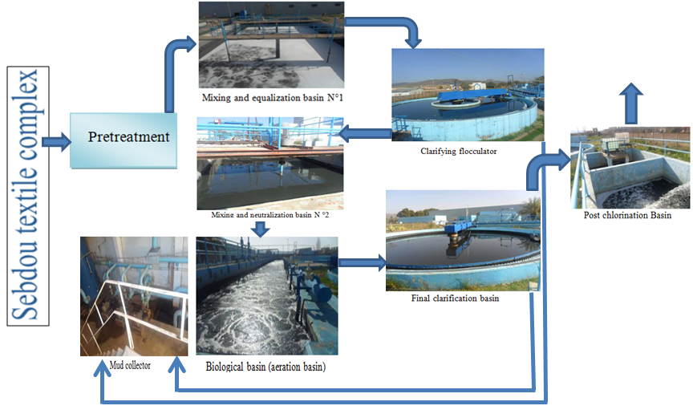

**Figure 1.** Schematic diagram of the physicochemical treatment process in the station of the textile industrial unit.

**2.3 Mixing and equalization basin n° 1**

Duis non mollis mi as shown in **Figure 2**, Lorem ipsum dolor sit amet, consectetur adipiscing elit. Sed finibus, lectus ac ornare ornare, enim purus consectetur ex, non lobortis magna leo eget tortor. Phasellus efficitur imperdiet ultricies Equation [1]. Etiam tincidunt orci nec dui bibendum venenatis.

| NaCl = W x | (1) |
| --- | --- |

where mauris convallis pellentesque lorem, et malesuada quam imperdiet eu. Praesent maximus nibh est, ac varius massa accumsan ut. Vivamus eget nisl a massa vestibulum porta vel sed nibh. Orci varius natoque penatibus et magnis dis parturient montes, nascetur ridiculus mus. Cras gravida ex in felis auctor consectetur sed eget augue. Nullam eget hendrerit felis, eget aliquam turpis. Vestibulum eu ullamcorper justo. Quisque fermentum pellentesque lectus, vel posuere ligula venenatis eget. Vestibulum mi orci, pharetra sit amet ullamcorper ut, pharetra non mauris. Suspendisse tempus ex at eros placerat, non viverra tortor pretium. Quisque mi nunc, tincidunt non elementum vel, accumsan eget felis. Aliquam id consequat elit.

**2.4. Rapid mixing and neutralization basin (physicochemical treatment)**

Nam feugiat ultrices nulla non facilisis as shown in **Figure 3**, Duis pellentesque sem sed nulla rhoncus, sit amet ultrices urna fermentum. Nam at est in massa lobortis finibus sit amet sit amet augue. Aenean iaculis, metus vel fringilla feugiat, nisl nisi ullamcorper odio, quis consectetur augue elit vel mauris. Curabitur sed ipsum id tortor accumsan aliquet a nec justo. Mauris blandit eleifend ante, vulputate tempor risus laoreet vitae. Nullam malesuada accumsan scelerisque. Aliquam erat volutpat. Vivamus sed diam erat. Pellentesque ullamcorper arcu eu orci finibus, vel feugiat tellus laoreet. Ut bibendum justo sit amet odio convallis, vel tincidunt enim maximus.

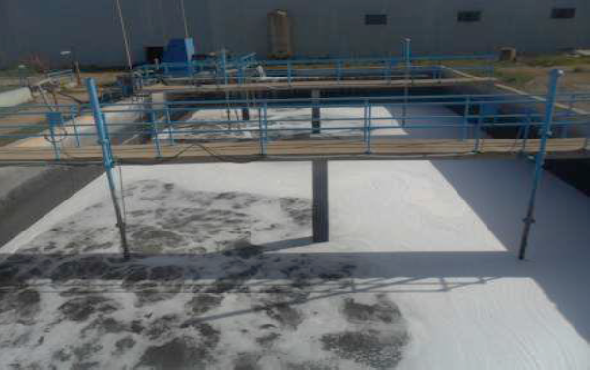

**Figure 2.** Photo of mixing and equalization basin N ° 1.

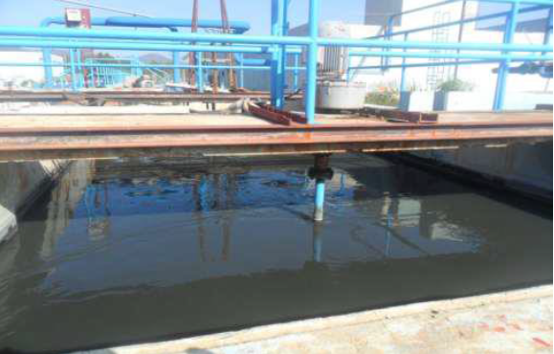

**Figure 3.** Mixing and neutralization basin N °2.

**2.5. Final clarification basin**

F Curabitur quam mi, mollis quis fringilla eu, ultricies in quam. Curabitur odio diam, venenatis nec elit ut, accumsan rhoncus lectus. Duis ut pulvinar orci. Ut vitae turpis sed dui ultrices iaculis gravida at purus. Mauris mollis, libero quis condimentum varius, tellus eros ullamcorper lacus, nec cursus ante dolor vitae urna. Praesent lacus elit, consectetur vitae tellus quis, dictum commodo est. Donec euismod convallis lacinia as shown in **Figure 6a**. **Figure 6b** shows the Nam at est in massa lobortis finibus sit amet sit amet augue. Aenean iaculis, metus vel fringilla feugiat, nisl nisi ullamcorper odio, quis consectetur augue elit vel mauris.

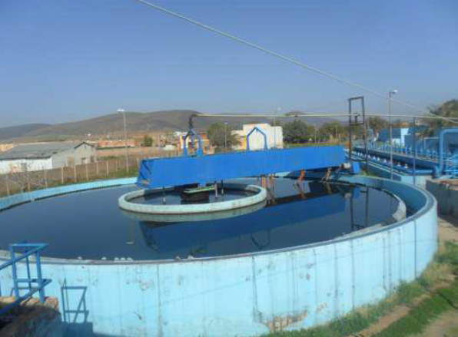

**Figure 4.** Clarifying flocculator.

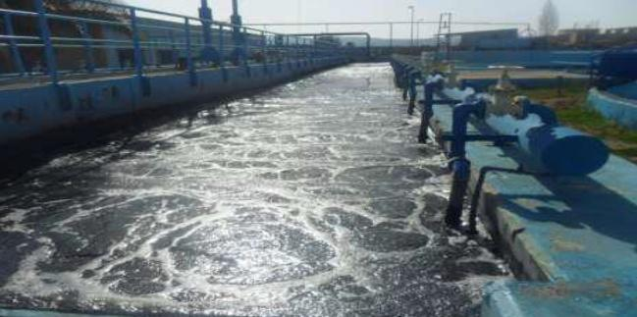

**Figure 5.** Biological basin (aeration basin).

|  |  |
| --- | --- |
| **Figure 6a.** Final clarification basin. | **Figure 6b.** Post chlorination basin. |

**3. RESULTS AND DISCUSSION**

**3.1. Temperature**

uspendisse in aliquam est, at consequat quam. Morbi porttitor orci augue. Vestibulum volutpat justo sed urna dictum, consequat condimentum nunc vestibulum. Ut nisi sem, consectetur at posuere nec, rhoncus sit amet magna. Phasellus eleifend orci dui, sit amet fringilla est malesuada non (Behera, *et al*., 2020). According to the results obtained in **Table 7** and **Figure 12**, Donec ac orci lacinia, imperdiet leo ut, blandit metus. Nam ut ante in velit fringilla luctus sit amet in purus. Vestibulum ante ipsum primis in faucibus orci luctus et ultrices posuere cubilia curae; Nam venenatis ipsum metus, eget lacinia odio gravida ac. Sed quis porttitor nisi. Nam tincidunt dapibus dui, vitae pulvinar nulla tincidunt sit amet. Nullam at mauris nulla. Aliquam ullamcorper metus eu dui auctor pulvinar. Vestibulum id ligula at lacus auctor euismod (Nolte, *et al*., 2020).

**Table 1.** The COD and BOD values for the last week of the month (final clarification output).

| **FINAL CLARIFICATION OUTPUT** | | | | | | | | | | |
| --- | --- | --- | --- | --- | --- | --- | --- | --- | --- | --- |
| **Day N°1** | | **Day N°2** | | **Day N°3** | | **Day N°4** | | | **Day N°5** | |
| COD  mg/ | COD  mg/ | COD  mg/ | COD  mg/ | COD  mg/ | COD  mg/ | | COD  mg/ | COD  mg/ | COD  mg/ | COD  mg/ |
| 130 | 36 | 162 | 44 | 153 | 28 | | 160 | 32 | 167 | 39 |

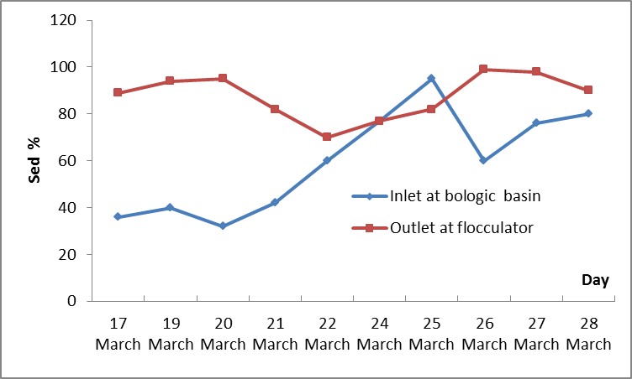

**Figure 12.** Daily variation in the sedimentation of the sludge at the outlet of the WWTP flocculator.

**4. CONCLUSION**

Lorem ipsum dolor sit amet, consectetur adipiscing elit. Sed finibus, lectus ac ornare ornare, enim purus consectetur ex, non lobortis magna leo eget tortor. Phasellus efficitur imperdiet ultricies. Etiam tincidunt orci nec dui bibendum venenatis. Mauris convallis pellentesque lorem, et malesuada quam imperdiet eu. Praesent maximus nibh est, ac varius massa accumsan ut. Vivamus eget nisl a massa vestibulum porta vel sed nibh. Orci varius natoque penatibus et magnis dis parturient montes, nascetur ridiculus mus. Cras gravida ex in felis auctor consectetur sed eget augue. Nullam eget hendrerit felis, eget aliquam turpis. Vestibulum eu ullamcorper justo. Quisque fermentum pellentesque lectus, vel posuere ligula venenatis eget. Vestibulum mi orci, pharetra sit amet ullamcorper ut, pharetra non mauris. Suspendisse tempus ex at eros placerat, non viverra tortor pretium. Quisque mi nunc, tincidunt non elementum vel, accumsan eget felis. Aliquam id consequat elit.

Nam feugiat ultrices nulla non facilisis. Curabitur facilisis commodo sapien vitae lobortis. Interdum et malesuada fames ac ante ipsum primis in faucibus. Nullam nibh nibh, suscipit vel magna a, tristique consequat ligula. Sed tempus metus leo, vel tempor lectus consequat ac. Donec semper et diam ac gravida. Sed vitae bibendum purus, ut ultricies nibh. Nunc consectetur euismod turpis, id molestie magna euismod a. Integer interdum iaculis venenatis. Quisque pellentesque pretium justo, nec congue nisl convallis sed. Etiam volutpat venenatis tortor, in tincidunt justo tristique non.

**5. ACKNOWLEDGMENT**

Nulla aliquet facilisis dignissim. Integer quis justo at mauris blandit viverra id at neque. Nunc sed consectetur nisi. Praesent dictum feugiat cursus.

**6. AUTHORS’ NOTE**

The authors declare that there is no conflict of interest regarding the publication of this article. Authors confirmed that the paper was free of plagiarism.

**7. REFERENCES**

Behera, B., and Sethi, N. (2020). Analysis of household access to drinking water, sanitation, and waste disposal services in urban areas of Nepal. *Utilities Policy*, *62*(2020), 100996.

Belbahloul, M., Abdeljalil, Z., and Abdellah, A. (2014). Comparison of the efficacy of two bioflocculants in water treatment*. International Journal of Scientific Engineering and Technology*. *3*(6), 734-737.

Bencheikh, I, Azoulay, K., Mabrouki, J., Hajjaji, S. E., Moufti, A., and Labjar, N. (2021). The use and the performance of chemically treated artichoke leaves for textile industrial effluents treatment. *Chemical Data Collections*, *31*(2021), 100597.

Heba, A., Eman, S. M. (2020). Co-sensitization of mesoporous ZnS with CdS and polyaniline for efficient photocatalytic degradation of anionic and cationic dyes. *Colloid and Interface Science Communications,* *39*(2020), 100330.

Khechekhouche, A., Benhaoua, B., Driss, Z.., Attia, M. E. H., and Manokar, M. (2020 A). polluted groundwater treatment in southeastern algeria by solar distillation. *Algerian Journal of Environmental and Sciences*, *6*(1).1207-1211.

Khechekhouche, A., Benhaoua, B., Manokar, M., Sathyamurthy, R., and Driss, Z. (2020). Sand dunes effect on the productivity of a single slope solar distiller. *Heat and Mass Transfer*, *56*(4), 1117-1126.

Khechekhouche, A., Bouchmel, F., Kaddour, Z., Salim, K., and Miloudi, A. (2020 C). Performance of a wastewater treatment plant in south-eastern Algeria. *International journal of Energetica*, *5*(2), 47-51.

Kim, Y. K., Yoo, K., Kim, M. S., Han, I., Lee, M., Kang, B. R., and Park, J. (2019). The capacity of wastewater treatment plants drives bacterial community structure and its assembly. *Scientific Reports*, *9*(1), 1-9.

Sadasivuni, K. K., Panchal, H., Awasthi, A., Israr, M., Essa, F. A., Shanmugan, S., and Khechekhouche, A. (2020). Ground water treatment using solar radiation-vaporization and condensation-techniques by solar desalination system. *International Journal of Ambient Energy*, 1-7 (*Accepted Manuscript*).

Stewart, E. J. (2012). Growing unculturable bacteria. *Journal of bacteriology*, *194*(16), 4151-4160.